Thesis Project

Building an Analytical Data Warehouse

Project Goal
The main goals of the project are:
- to create a data warehouse using a multi-layer architecture (NDS and DDS);
- develope ETL processes for loading, processing, and analyzing data;
- build data marts for visualizing key metrics of store performance.
The objective of this work is to demonstrate a grasp of key concepts in the subject area and skills in working with essential tools that are in demand today in the field of data engineering.

Project Tasks
- Data Processing:
  - Obtaining raw data from CSV files
  - Data cleaning and normalization
- Development of the Data Warehouse structure:
  - NDS: normalized model for reliable data storage
  - DDS: creation of fact and dimension tables for analytics (star schema)
  - Data Quality: data quality checks
  - Metadata: monitoring the execution of ETL processes
- Creating ETL Processes:
  - Developing processes for loading data from “stage” layer to NDS and DDS layers
  - Orchestrating ETL processes
- Data Visualization:
  - Building dashboards to display key metrics
  - Implementing dashboards for monitoring data quality (metadata and load statuses)

Technologies Stack
- PostgreSQL 12.9 — DBMS for implementing the data warehouse
- Python (pandas, faker) 3.11.9 — for processing and generating daily store reports
- Apache Airflow 2.10.2 — for automating and orchestrating ETL processes
- Docker 27.2.0 — for containerizing services
- PowerBI Desktop 2.137.952.0 64-bit — for creating interactive dashboards
Table of Contents
Project Goal 1
Project Tasks 1
Technologies Stack 1
Project Phases 4
Obtaining Raw Data 5
Daily Reports Generation based on raw data 6
1. Tasks of the Section 6
2. Technology Stack and Process Description 6
3. New data generation 6
Development of Database Schemas as Part of Data Warehouse Design 8
Formation of the Staging Layer of the Data Warehouse 9
stage.kaggle_sales 9
stage.kaggle_sales_ready 9
stage.days_off 10
Formation of the NDS Layer of the Data Warehouse 11
nds.orders 11
nds.payments 11
nds.payment_types 12
nds.cities 12
nds.branches 12
nds.branches_cities 12
nds.product_lines 12
nds.products 13
nds.customer_types 13
nds.customers 13
Formation of the DDS Layer of the Data Warehouse 14
dim.dates 14
fact.sales_items 14
dim.branches 15
dim.cities 15
dim.branches_cities 15
dim.functional_structure 15
dim.products 16
dim.payment_types 16
dim.customers 16
Formation of the Data Quality Layer 17
dq.stage_kaggle_sales 17
dq.nds_orders 17
dq.nds_invoice_customers 18
dq.dds_trends 18
Formation of the Metadata Layer 19
metadata.etl_status 19
Building Dashboards 20
1. Tasks of the Section 20
2. BI Tool Used 20
3. Data Source 20
4. Model 20
5. Visualizations 22
Building ETL Processes and Orchestration 25
1. Tasks of the Section 25
2. Process description 25
2.1. Data quality check (DQ) in the stage layer: 25
2.2. Loading Data into the NDS Layer: 26
2.3. Logging the Load to the NDS Layer 26
2.4. Loading Data into the DDS Layer: 26
2.6. Updating Statuses in the Metadata Table 27
2.7. Parallel update of Power BI dashboards 27
3. ETL process Topology 27
4. Possible enhancements and improvements 28
5. Data that did not pass quality checks 28
Data Transformation with dbt 29
1. Tasks of the Section 29
2. Connection Setup 29
3. DAG Setup / Managing Model Dependencies 30
4. Model Descriptions 30
5. Snapshot Descriptions 31
6. Creating Documentation 31
Results and Conclusions 33

Project Phases
- Obtaining raw data
- Generation daily reports based on the raw data
- Schemas development as part of data warehouse design
- Creation the ‘stage’ layer of the data warehouse
- Creation the NDS layer of the data warehouse
- Creation the DDS layer of the data warehouse
- Creation the data quality layer
- Creation the metadata layer
- Building dashboards
- Building ETL processes and orchestration

Obtaining Raw Data
The raw dataset is available online at:
https://www.kaggle.com/datasets/aungpyaeap/supermarket-sales
This dataset, in CSV format, contains information about sales from three stores of a unified retail chain located in three cities.
The dataset consists of 1000 rows and 17 columns:
- Invoice id: Computer generated sales slip invoice identification number
- Branch: Branch of supercenter (3 branches are available identified by A, B and C).
- City: Location of supercenters
- Customer type: Type of customers, recorded by Members for customers using member card and Normal for without member card.
- Gender: Gender type of customer
- Product line: General item categorization groups - Electronic accessories, Fashion accessories, Food and beverages, Health and beauty, Home and lifestyle, Sports and travel
- Unit price: Price of each product in $
- Quantity: Number of products purchased by customer
- Tax: 5% tax fee for customer buying
- Total: Total price including tax
- Date: Date of purchase (Record available from January 2019 to March 2019)
- Time: Purchase time (10am to 9pm)
- Payment: Payment used by customer for purchase (3 methods are available – Cash, Credit card and Ewallet)
- COGS: Cost of goods sold
- Gross margin percentage: Gross margin percentage
- Gross income: Gross income
- Rating: Customer stratification rating on their overall shopping experience (On a scale of 1 to 10)

Daily Reports Generation based on raw data

Tasks of the Section
Since the data from the raw dataset is insufficient to simulate the admission of new data, a data generator was written. This generator creates data identical in form and content to the original dataset, adding approximately ~ 1200 new rows daily to the staging layer.
To test the data quality mechanism, a certain percentage of corrupted data is intentionally included, which does not meet the data quality requirements.

Technology Stack and Process Description
Data generation is implemented through a Python script. For educational purposes and in order to create conditions similar to real-life scenarios, the script is placed in a Docker container; the data is exported via a volume accessible on the external host.
The artifact is a CSV file named ‘new_daily_data.csv’, which is then processed by a stored procedure in PostgreSQL, after which the data is moved to the “stage” layer in the table stage.kaggle_sales_ready. The execution of the stored procedure is triggered through a .bat script named call_procedure_sql.bat.
For educational purposes, the Ubuntu crontab is used as the scheduler. It is worth noting that the other orchestration tasks in this project are handled using Apache Airflow.

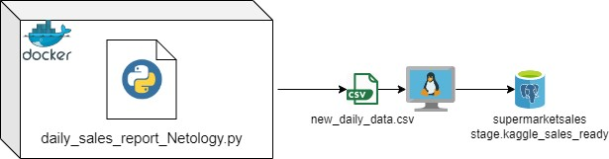

New data generation
Data is generated in the Docker container via the script daily_sales_report_Netology.py. In the crontab, the script is scheduled to run daily at 7:00 AM. Using a volume mounted through the HOST_PATH variable, the output artifact of the script is transferred from the container to the host, specifically to the directory D:\.
Further, a .bat script named call_procedure_sql.bat copies the artifact to the PostgreSQL directory on the C:\ drive since the COPY FROM command for loading data into the database could only be executed from this directory. It then initiates the execution of the stored procedure stage.load_raw_data() in PostgreSQL, which directly loads the data into the database.

The second command in the crontab serves as the scheduler for executing call_procedure_sql.bat.
Thus, according to the schedule:
1. New data is generated for our data warehouse.
2. The data is loaded into the stage layer using the ‘call_procedure_sql.bat’ script, which in turn calls the stored procedure ‘load_raw_data()’.

It is important to note that within the aforementioned call_procedure_sql.bat, a separate SQL script call_procedure_script.sql is invoked, which simply executes the command CALL stage.load_raw_data();

Adjusting the crontab:
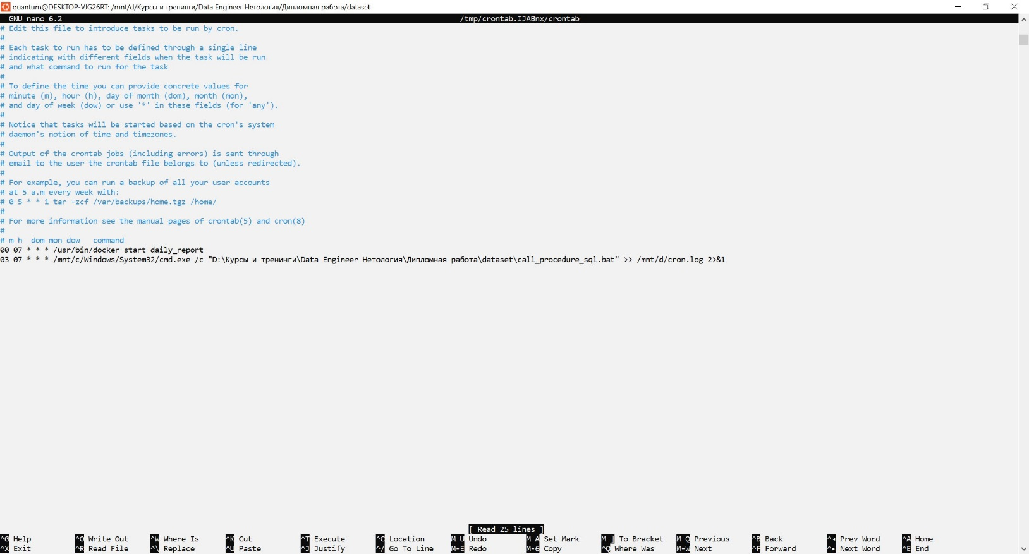

Development of Database Schemas as Part of Data Warehouse Design
The database (hereinafter referred to as the DB) supermarketsales simulates a data warehouse (hereinafter referred to as the DW) according to the Inmon model, featuring a three-layer architecture.
List of Database Schemas:
No. | Schema Name | Purpose of the Schema
1 | stage | Simulates the raw layer of the DW
2 | nds | Simulates the normalized layer of the DW
3 | dim | Simulates the data mart layer
4 | fact | Simulates the data mart layer
5 | dq | Data quality control framework
6 | metadata | Metadata framework

Formation of the Staging Layer of the Data Warehouse
In this layer, the initial placement of data occurs during loading from external sources. To speed up INSERT operations, there are no indexes on the tables.

stage.kaggle_sales
Data from the original dataset and subsequent daily reports initially enters this table in AS IS format, without any transformations.
Attribute | Type | Description
invoice_id | varchar(16) | Invoice identification number for payment
branch | varchar(1) | Branch of the supermarket
city | varchar(16) | City of the supermarket location
customer_type | varchar(8) | Customer type based on loyalty program affiliation
gender | varchar(8) | Gender of the customer
product_line | varchar(32) | Product category
unit_price | float4 | Price of the product per unit
quantity | int4 | Number of products purchased by the customer
tax_5 | float4 | 5% tax fee for customers
total | float4 | Total purchase amount including tax
date_ | varchar(16) | Purchase date
time_ | varchar(8) | Purchase time
payment | varchar(16) | Payment method used by the customer for purchase
cogs | float4 | Revenue excluding tax
gross_margin_percentage | float4 | Gross margin percentage
gross_income | float4 | Gross income
rating | float4 | Customer satisfaction rating

stage.kaggle_sales_ready
Data type conversions occur here, and a technical column check_status and a synthetic column product_id are added.
Attribute | Type | Description
invoice_id | varchar(16) | Invoice identification number for payment
branch | varchar(1) | Branch of the supermarket
city | varchar(16) | City of the supermarket location
customer_type | varchar(8) | Customer type based on loyalty program affiliation
gender | varchar(8) | Gender of the customer
product_line | varchar(32) | Product category
unit_price | numeric(10, 2) | Price of the product per unit
quantity | int4 | Number of products purchased by the customer
tax_5 | numeric(10, 2) | 5% tax fee for customers
total | numeric(18, 2) | Total purchase amount including tax
date_ | date | Purchase date
time_ | varchar(20) * | Purchase time
payment | varchar(16) | Payment method used by the customer for purchase
cogs | numeric(18, 2) | Revenue excluding tax
gross_margin_percentage | float4 | Gross margin percentage
gross_income | numeric(10, 2) | Gross income
rating | numeric(4, 1) | Customer satisfaction rating
check_status | int4 | Data quality check flag based on data quality algorithms
product_id | int4 | Product identifier; artificially introduced into the dataset for integrity and consistency in subsequent calculations and transformations.
* The data type for time_ is intentionally left as varchar(20) to demonstrate the functioning of data quality mechanisms; while using the time data type is acceptable, in that case, low-quality data would simply not be processed by the detection algorithms. Moreover, the import process for new report data would be interrupted, requiring an error handler regardless.

stage.days_off
This dataset imports information about weekends, holidays, pre-holidays, and non-working days.
Atribute | Type | Description
date | varchar(10) | Date in text format
type | varchar(20) | Type of date: weekend/holiday, pre-holiday/non-working day (during COVID-19)

Formation of the NDS Layer of the Data Warehouse
In this layer, the data is normalized and brought in line with the requirements of the Third Normal Form (3NF).
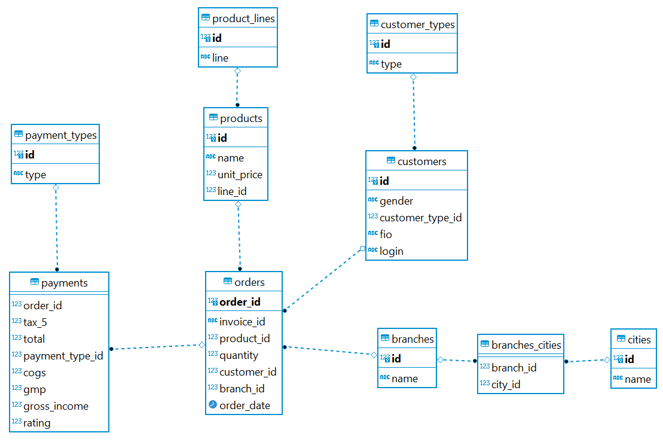

nds.orders
Orders table.
Attribute | Type | Description
order_id | serial4 | Order identification number
invoice_id | varchar(16) | Invoice identification number for payment
product_id | int4 | Product identification number
quantity | int4 | Quantity of the product in the order
customer_id | int4 | Customer identification number
branch_id | int4 | Branch identification number
order_date | timestamp | Order creation date

The nds.orders table has a PRIMARY KEY on the order_id attribute and three FOREIGN KEYs: product_id, customer_id, and branch_id.
To enhance the performance of queries on the branch_id, customer_id, and invoice_id attributes, indexes have been created.

nds.payments
Payments table.
Attribute | Type | Description
order_id | int4 | Order identification number
tax_5 | decimal(10, 2) | 5% tax
total | decimal(18, 2) | Total amount
payment_type_id | int4 | Payment type identification number
cogs | decimal(18, 2) | Cost of goods sold
gmp | float4 | Gross margin percentage
gross_income | decimal(10, 2) | Gross profit
rating | decimal(4, 1) | Rating
The nds.payments table has two FOREIGN KEYs: order_id and payment_type_id.
A covering index payments_idx_branches is created for order_id, including fields tax_5, total, cogs, and gross_income, while for payment_type_id, the index payments_idx_payment_types is established.

nds.payment_types
Payment types table.
Attribute | Type | Description
id | serial | Payment type identification number
type | varchar(30) | Name of the payment type
The nds.payment_types table has a PRIMARY KEY on the id attribute.

nds.cities
Cities table.
Attribute | Type | Description
id | serial | City identification number
name | varchar(100) | Name of the city
The nds.cities table has a PRIMARY KEY on the id attribute.

nds.branches
Branches Table.
Атрибут | Тип | Описание
id | serial | Идентификатор филиала
name | varchar(2) | Название филиала
The nds.branches table has a PRIMARY KEY on the id attribute.

nds.branches_cities
Branches-Cities relationship table.
Attribute | Type | Description
branch_id | int | Branch identification number
city_id | int | City identification number
The nds.branches_cities table has two FOREIGN KEYs: branch_id and city_id.

nds.product_lines
Product categories table
Attribute | Type | Description
id | serial | Category identification number
line | varchar(100) | Name of the category
The nds.product_lines table has a PRIMARY KEY on the id attribute.

nds.products
Products table.
This is a synthetic reference table created for data consistency and integrity in the project..
Attribute | Type | Description
id | serial | Product identification number
name | varchar(100) | Name of the product
unit_price | decimal(10, 2) | Price per unit of the product
line_id | int | Product category identification number
The nds.products table has a PRIMARY KEY on the id attribute and a FOREIGN KEY on line_id. An index n_idx is also created for line_id.

nds.customer_types
Customer types table.
Attribute | Type | Description
id | serial | Customer type identification number
type | varchar(100) | Name of the customer type
The nds.customer_types table has a PRIMARY KEY on the id attribute.

nds.customers
Customers table.
Another synthetic reference table. The data was generated using the Faker library in Python.
Attribute | Type | Description
id | serial | Customer identification number
gender | varchar(6) | Gender of the customer
customer_type_id | int | Customer type identification number
fio | varchar(200) | Full name of the customer
login | varchar(50) | Customer login
The nds.customers table has a PRIMARY KEY on the id attribute and a FOREIGN KEY on customer_type_id. An index customers_idx is created for customer_type_id.

Formation of the DDS Layer of the Data Warehouse
The dim and fact schemas together represent the DDS layer. In this layer, data is stored in a format convenient for building data marts. The schema topology is a star schema.

dim.dates
Dates table.
Attribute | Type | Description
id | serial | Date identification number in the format YYYYMMDD
date | date | Date
ansi_date | varchar(10) | Date in the format YYYY-MM-DD
day | int4 | Day of the week (1-7)
week_number | int4 | Week number in the year
month | int4 | Month number (1-12)
year | int4 | Year
week_day | int4 | Workday flag
holiday | boolean | Holiday flag
preholiday | boolean | Pre-holiday flag
nowork | boolean | Non-working day flag (during COVID-19)
The dim.dates table has a PRIMARY KEY on the id attribute and is clustered on this index.
To improve query performance, the following indexes are also created:
- dates_dt_idx on the date column
- month_dt_idx on the month column
- year_dt_idx on the year column

fact.sales_items
Sales items table.
Attribute | Type | Description
date_key | int | Date identification number
transaction_date | timestamp | Date and time of the order
order_id | int | Order identification number
customer_key | int | Customer identification number
payment_type_id | int | Payment type identification number
branch_id | int | Branch identification number
city_id | int | City identification number
product_key | int | Product identification number
quantity | int | Quantity of products sold
cogs | decimal(18, 2) | Revenue
tax_5 | decimal(10, 2) | 5% tax
total | decimal(18, 2) | Total sales amount
gmp | real | Gross margin percentage
gross_income | decimal(10, 2) | Gross profit
rating | decimal(4, 1) | Customer satisfaction rating
he fact.sales_items table has several FOREIGN KEYs:
- date_key references dim.dates(id);
- order_id references nds.orders(order_id);
- customer_key references dim.customers(id);
- payment_type_id references dim.payment_types(id);
- product_key references dim.products(id)
To enhance query performance, the following indexes are created:
- Covering index (cogs, tax_5, total, gross_income) on the columns (date_key, order_id) as fact_idx_date_
- fact_idx_trans_date on the transaction_date column
- fact_idx_date_order_id on the order_id column
- fact_idx_date_cust_key on the customer_key column
- fact_idx_date_ptype_id on the payment_type_id column
- fact_idx_date_prod_key on the product_key column
- fact_idx_date_rating on the rating column
- year_dt_idx on the year column

dim.branches
Branches reference table.
Attribute | Type | Description
id | int | Branch identification number
name | varchar(100) | Name of the branch
The dim.branches table has a PRIMARY KEY on the id attribute.
An index dim_idx_branches is created on the id column.

dim.cities
Cities reference table
Attribute | Type | Description
id | int | City identification number
name | varchar(100) | Name of the city
The dim.cities table has a PRIMARY KEY on the id attribute.
An index dim_idx_cities is created on the id column..

dim.branches_cities
Branches-Cities relationship table
Attribute | Type | Description
branch_id | int | Branch identification number
city_id | int | City identification number
The dim.branches_cities table has two FOREIGN KEYs:
- branch_id references dim.branches(id)
- city_id references dim.cities(id)

dim.functional_structure
Functional structure reference table
Attribute | Type | Description
branch_id | int | Branch identification number
branch | varchar(2) | Name of the branch
city_id | int | City identification number
city | varchar(100) | Name of the city
The dim.functional_structure table has a PRIMARY KEY on the branch_id and city_id attributes.
An index dim_idx_fs is created on the city_id column.

dim.products
Products reference table
Attribute | Type | Description
id | int | Product identification number
product_name | varchar(100) | Name of the product
unit_price | decimal(10, 2) | Price per unit of the product
product_line | varchar(100) | Product category
The dim.products table has a PRIMARY KEY on the id attribute.
An index dim_idx_products is created on the id column.

dim.payment_types
Payment types reference table
Attribute | Type | Description
id | int | Payment type identification number
payment_type | varchar(30) | Name of the payment type
The dim.payment_types table has a PRIMARY KEY on the id attribute.
An index dim_idx_payment_types is created on the id column.

dim.customers
Customers reference table.
Attribute | Type | Description
id | serial | Customer identification number in the DDS layer
customer_id | int | Customer identification number in the NDS layer
customer_type | varchar(100) | Customer type based on the loyalty program
gender | varchar(6) | Gender of the customer
fio | varchar(200) | Full name of the customer
login | varchar(50) | Customer login
active_from | int | Date of customer registration in the system
active_to | int | Date of customer removal from the system / data modification
The dim.customers table has a PRIMARY KEY on the id attribute.
This relationship is the Slowly Changing Dimension (SCD) Type 2.
The following indexes have been created:
- Covering index (gender, fio, login) dim_idx_customers_main on the id column
- dim_idx_customers on the customer_id
- dim_idx_active on the columns (active_from, active_to)

Formation of the Data Quality Layer
The dq schema contains data that did not pass the quality checks.
dq.issues
Issues Reference Table
Attribute | Type | Description
id | serial | Issue identification number
desc | varchar(200) | Description of the issue
The dq.issues table has a PRIMARY KEY on the id attribute.

dq.stage_kaggle_sales
Table of poor quality data identified in the stage layer
Attribute | Type | Description
invoice_id | varchar(16) | Invoice identification number for payment
branch | varchar(1) | Branch of the supermarket
city | varchar(16) | City of the supermarket location
customer_type | varchar(8) | Customer type based on loyalty program affiliation
gender | varchar(8) | Gender of the customer
product_line | varchar(32) | Product category
unit_price | numeric(10, 2) | Price of the product per unit
quantity | int | Number of products purchased by the customer
tax_5 | numeric(10, 2) | 5% tax fee for customers
total | numeric(18, 2) | Total purchase amount including tax
date | date | Purchase date
time | varchar(20) | Purchase time
payment_type | varchar(16) | Payment method used by the customer for purchase
cogs | numeric(18, 2) | Revenue excluding tax
gross_margin_percentage | float4 | Gross margin percentage
gross_income | numeric(10, 2) | Gross income
rating | numeric(4, 1) | Customer satisfaction rating
issue_id | int | Issue identification number
The dq.stage_kaggle_sales table has a FOREIGN KEY on the issue_id.

dq.nds_orders
Table of poor quality data identified in the nds layer.
This table contains anomalous data for days where the number of orders significantly exceeds the daily norm, as well as identified problematic cases where the revenue reported in the original dataset in the ‘cogs’ column differs from the revenue calculated in the nds.orders table by multiplying the ‘quantity’ and ‘unit_price’ attributes.
Attribute | Type | Description
order_date | date | Order date
num_orders | int | Number of orders
cogs_from_nds | decimal(18, 2) | Revenue from NDS
cogs_check_sum | decimal(18, 2) | Revenue from staging
issue_id | int | Issue identification number
he dq.nds_orders table has a FOREIGN KEY on the issue_id.

dq.nds_invoice_customers
Table of poor quality data identified in the nds layer.
This table contains anomalous cases where there is more than one customer per order.
Attribute | Type | Description
invoice_id | varchar(16) | Invoice identification number for payment
order_date | timestamptz | Order date
num_customers | int8 | Number of customers attached to the order
issue_id | int | Issue identification number
The dq.nds_invoice_customers table has a FOREIGN KEY on the issue_id.

dq.dds_trends
Trends table.
This table contains aggregated data on the average number of orders per day and the daily total of orders.
Attribute | Type | Description
check_date | date | Date of the check
avg_num_orders | int | Average number of orders
delta_avg_num_orders | int | Change in the average number of orders
avg_total | int | Average total of orders
delta_avg_total | int | Change in the average total of orders
The dq.dds_trends table has no constraints or indexes.

Formation of the Metadata Layer
The metadata schema contains metadata about the status of ETL processes and the number of affected rows.

metadata.etl_status
ETL status table.
Attribute | Type | Description
id | serial | Record identification number in the table
dag_id | text | DAG identification number
task_id | text | Task identification number
execution_date | timestamp | Date and time of task_id execution
status | text | Status of task_id execution
rows_processed | int | Number of rows processed in task_id
target_table | text | Target table where data was loaded
last_row_count | int | Total number of rows in the target table at the time of the record creation in metadata.etl_status
created_at | timestamp | Date and time of record creation
The metadata.etl_status table has a PRIMARY KEY on the id attribute.
The following indexes have been created:
- md_idx_date_load on the execution_date column
- md_idx_date_target on the target_table column

Building Dashboards

Tasks of the Section
To demonstrate successful integration of BI tools with the data mart layer (DDS) in the data warehouse.

BI Tool Used
Microsoft PowerBI Desktop 2.137.952.0 64-bit

Data Source
The data source is the supermarketsales DB, specifically the fact, dim, and metadata schemas.
The connection is established through the native connector for PostgreSQL.
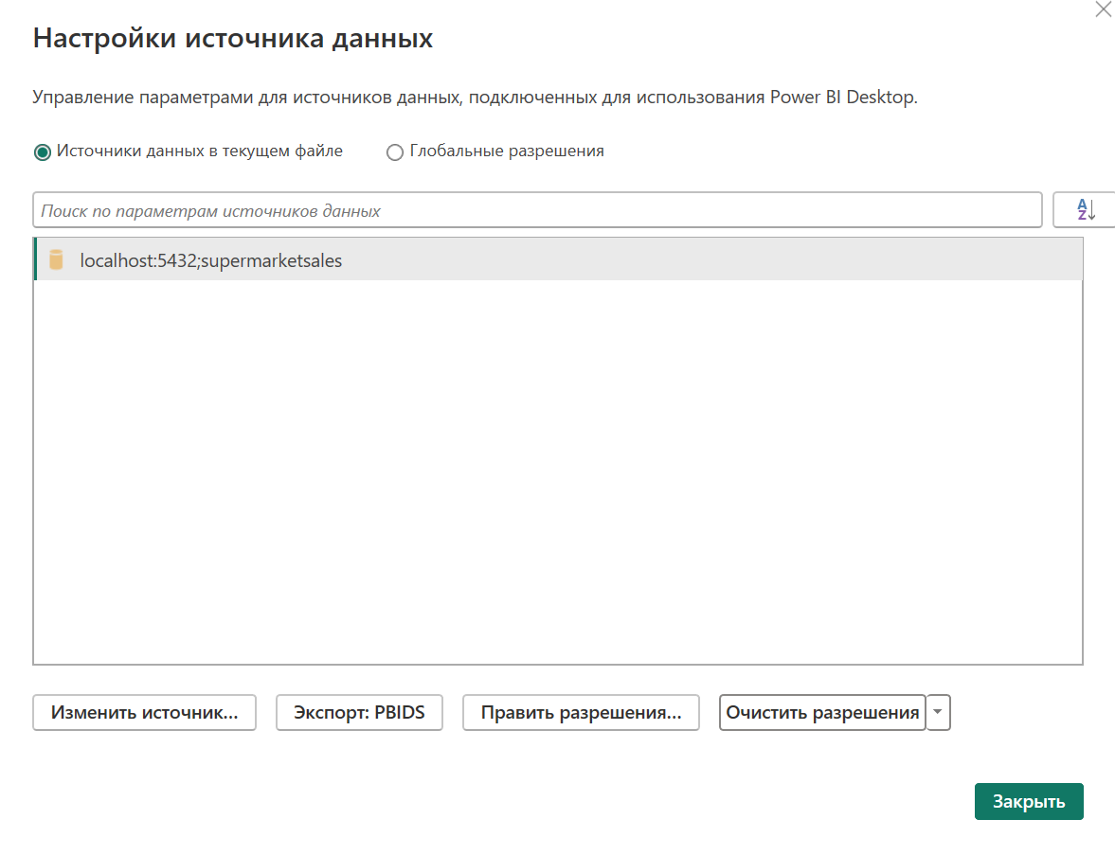

Model
- One-to-many (1:*) relationships are established between the dimension tables and the fact table.
There are also one-to-one (1:1) relationships between the dates table and the tables for holidays, pre-holidays, and non-working days;
- the dates table is defined;
- data types for the columns are configured, and display settings for columns and measures in the visualizations are adjusted;
- the necessary measures are prepared.

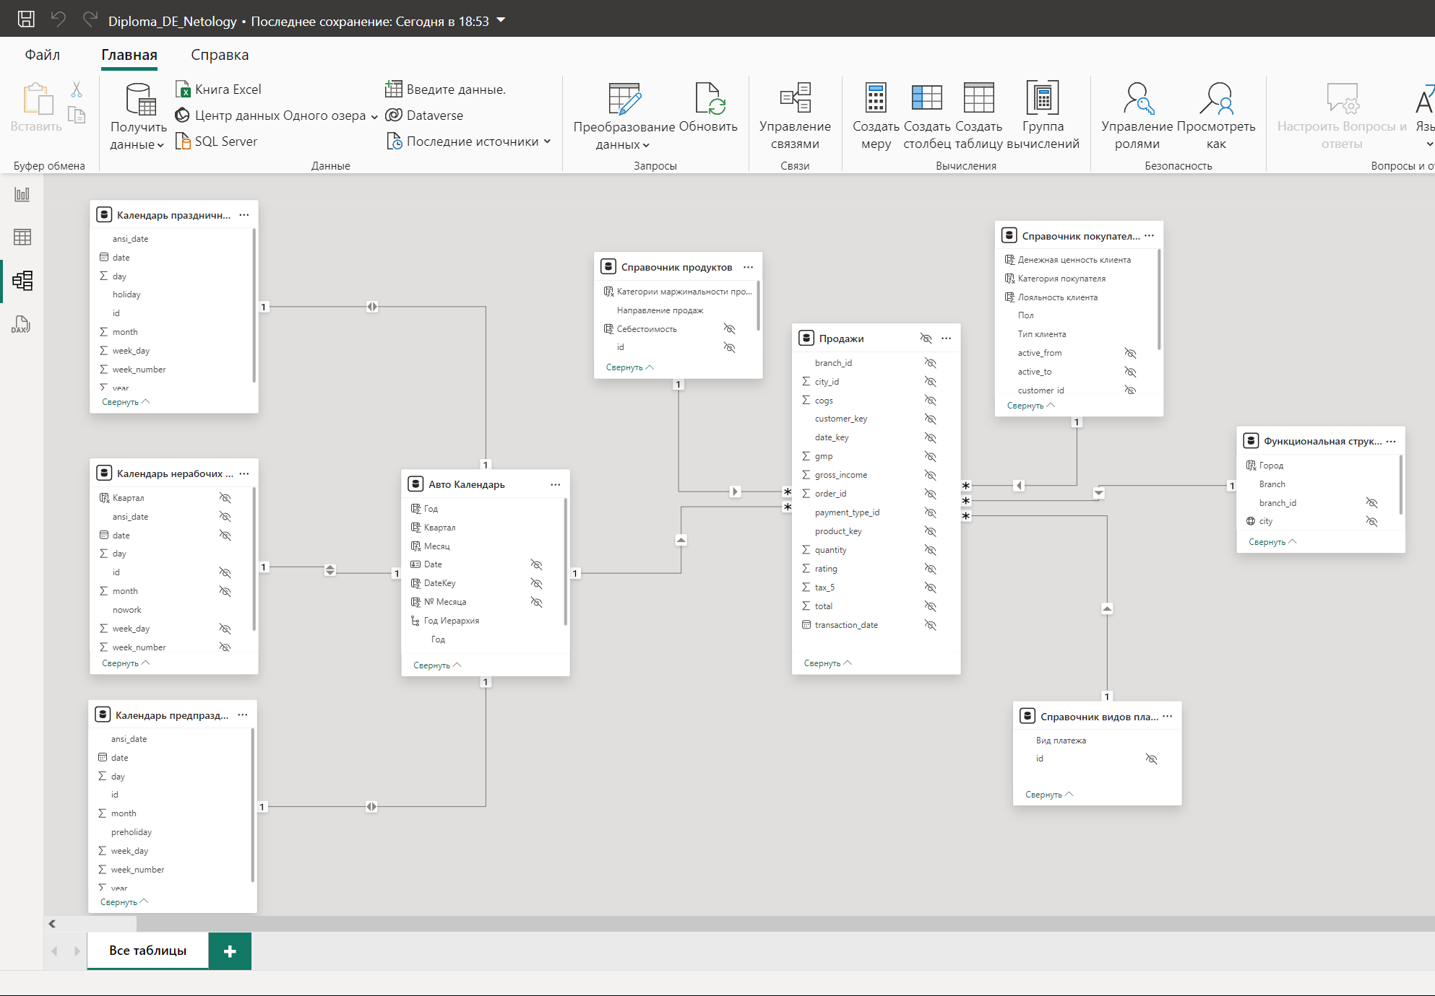

Visualizations
The main dashboard – «Sales Report»
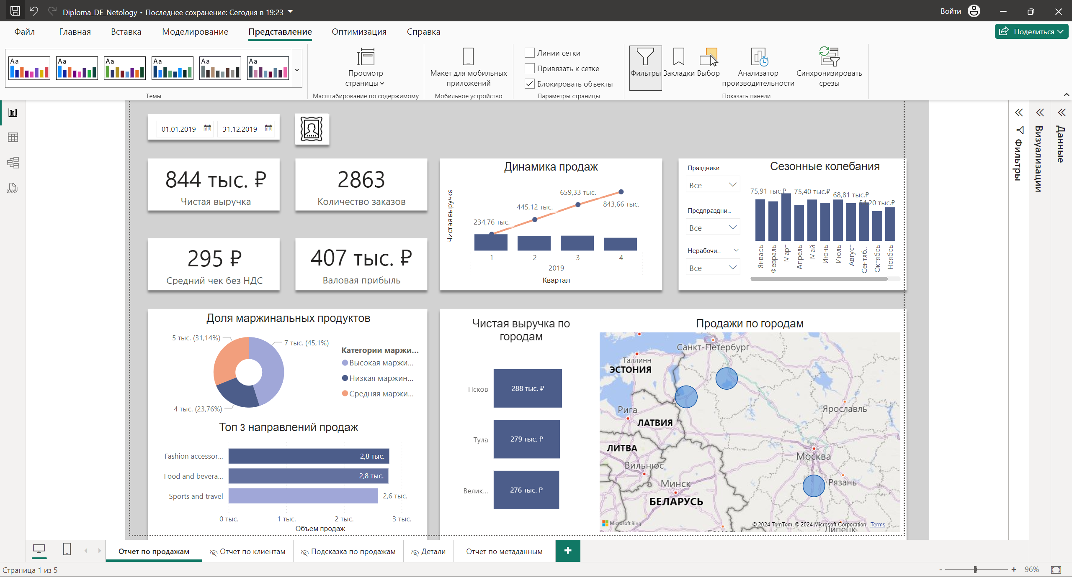
Key Components:
- Overall Metrics:
- Total Sales: Quantity of products sold
- Number of Orders: Total number of orders
- Average Check: Average amount of a single order
- Net Revenue: Total value of sold products
- Cumulative Net Revenue since the beginning of the year
- Gross Profit: Difference between total sales and cost of goods sold
- Trends Over Time:
- Sales dynamics by days/months/years.
- Seasonal fluctuations: Analysis of peak sales periods related to holidays or promotions..
- Regional Analysis:
- Sales by cities and branches:
- Product Category Analysis:
- Top 3 sales directions
- Product segmentation by margin level
- Customer Profile
- Drill-down and Tooltips:
- A page is prepared for tooltips, providing extended information in the form of a tabular reference on sales in the given context.
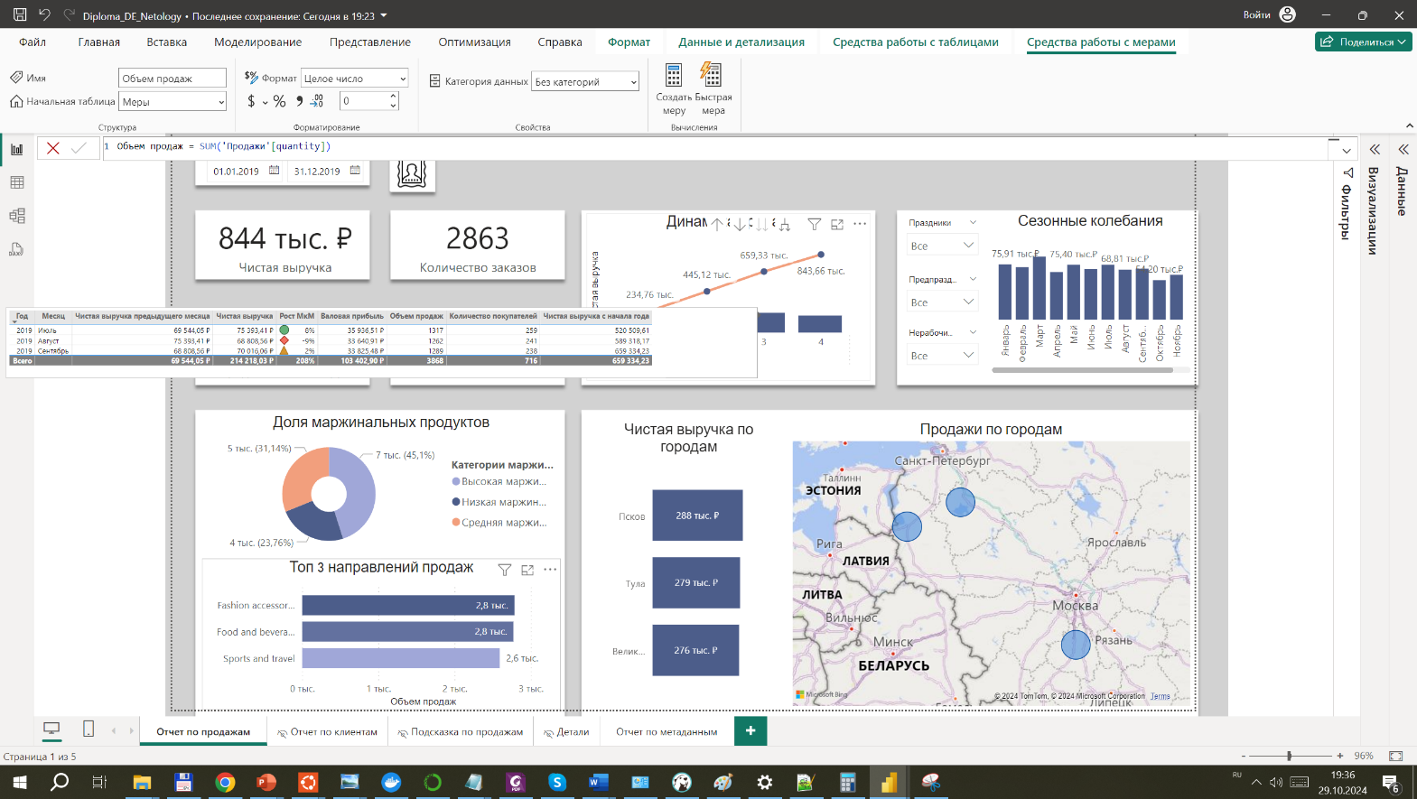
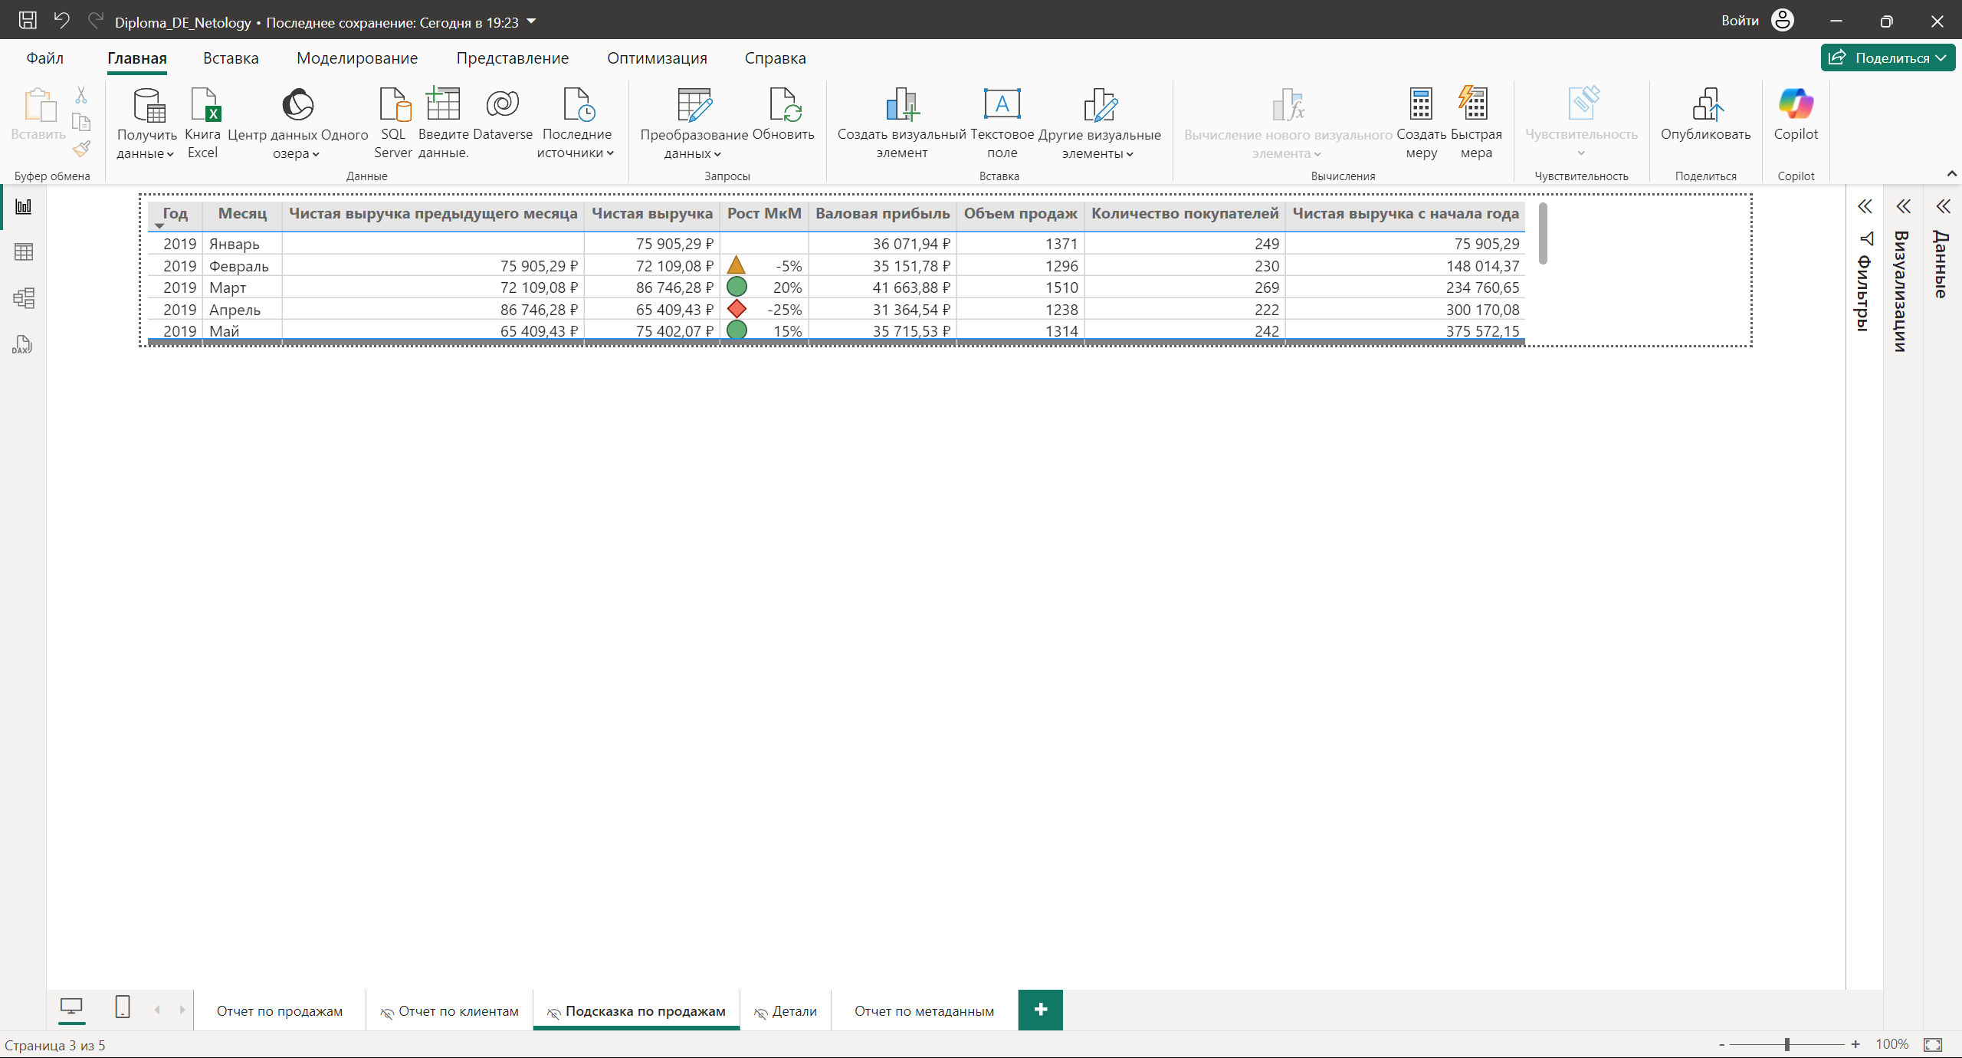

- Additional information is displayed as a tooltip when hovering the cursor over elements:
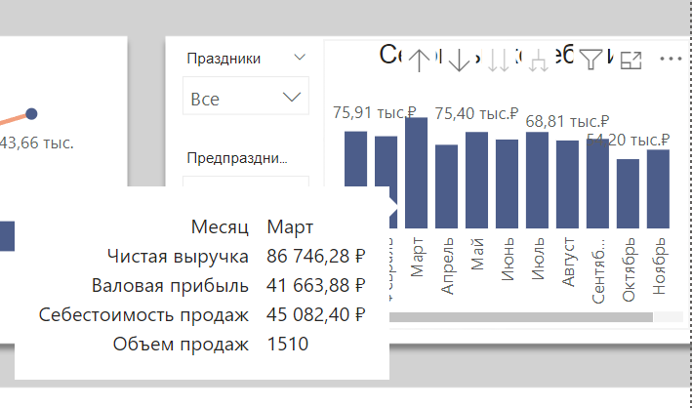
- A customer profile has been compiled:
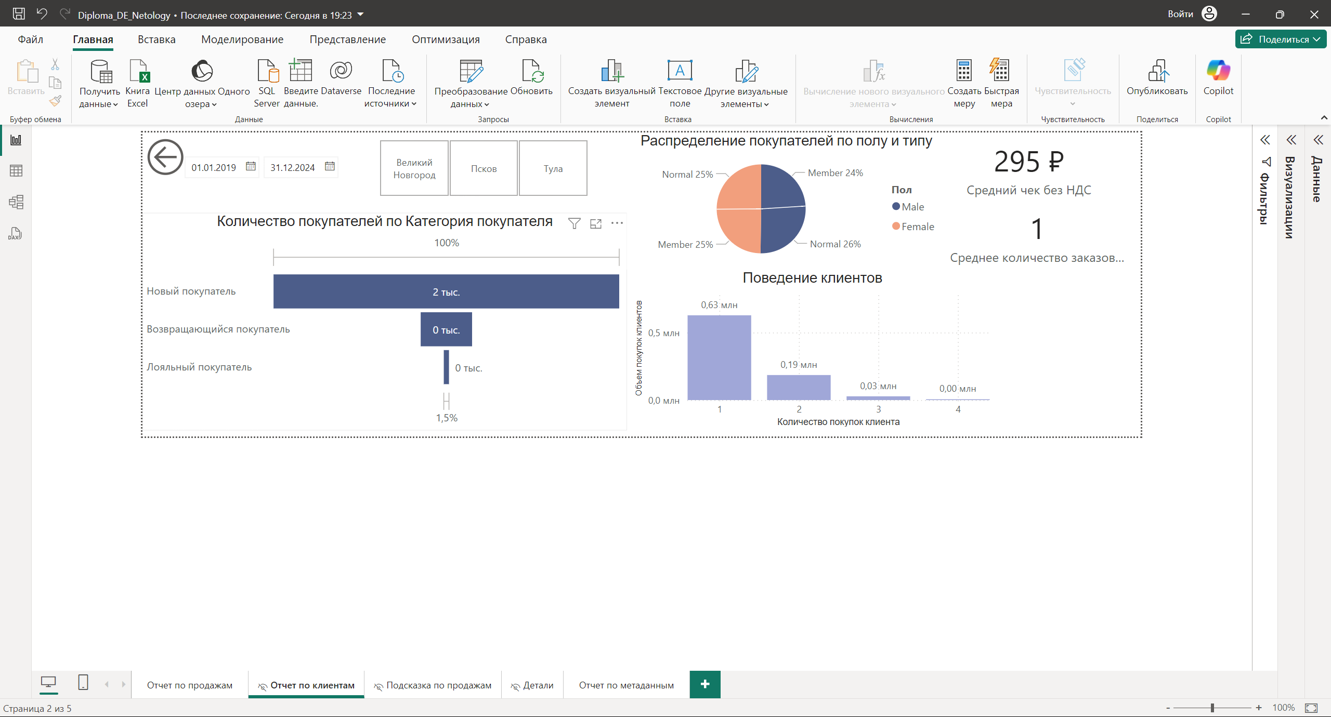
- A dashboard with technical information from the metadata layer has been implemented:
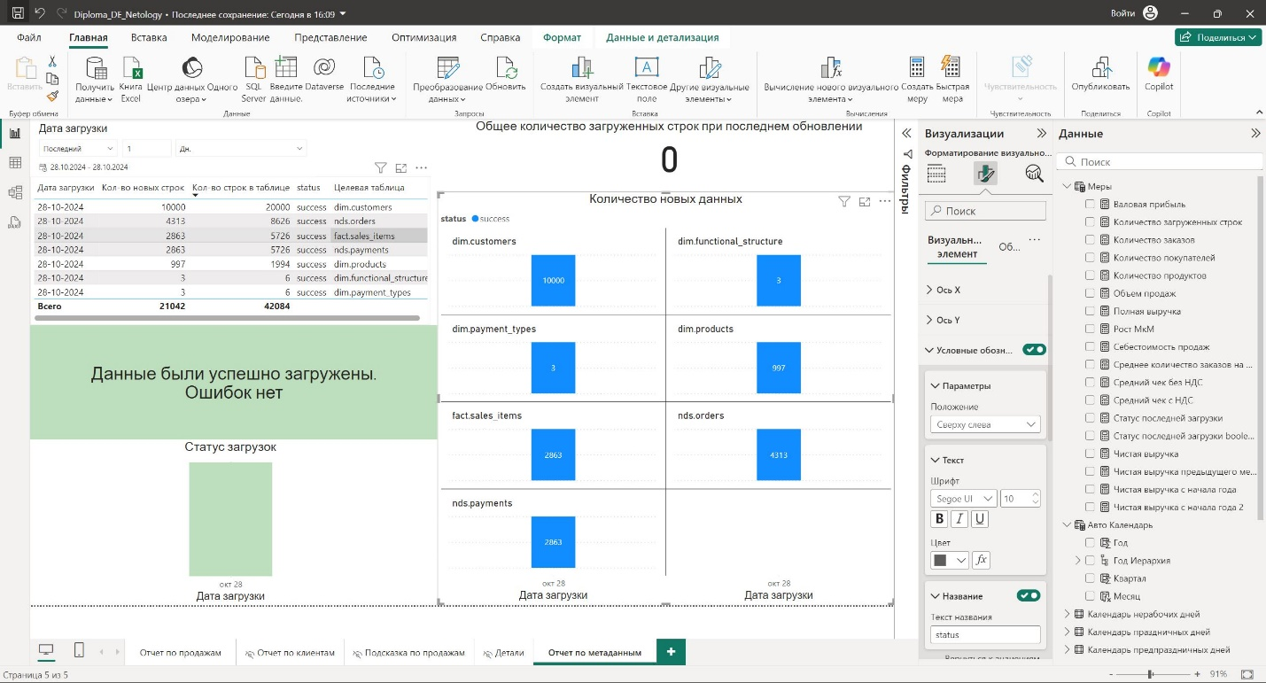

Building ETL Processes and Orchestration

Tasks of the Section
To develop and configure ETL processes to ensure reliable and timely delivery of data to the data warehouse.
Apache Airflow version 2.10.2, based on Python 3.10.12, has been chosen as the orchestrator and ETL loader, working in conjunction with PostgreSQL 12.9.
To accomplish this task, a single Directed Acyclic Graph (DAG) was developed, providing:
- Quality control, data integrity maintenance, and loading of data from the raw staging layer (stage) to the normalized layer (nds);
- Quality control, data integrity maintenance, and transfer of data from the nds layer to the data mart layer (dds);
- Logging of metadata, such as task execution status and amount of processed information.
DAG Name: etl_supermarketsales_DQ_metadata
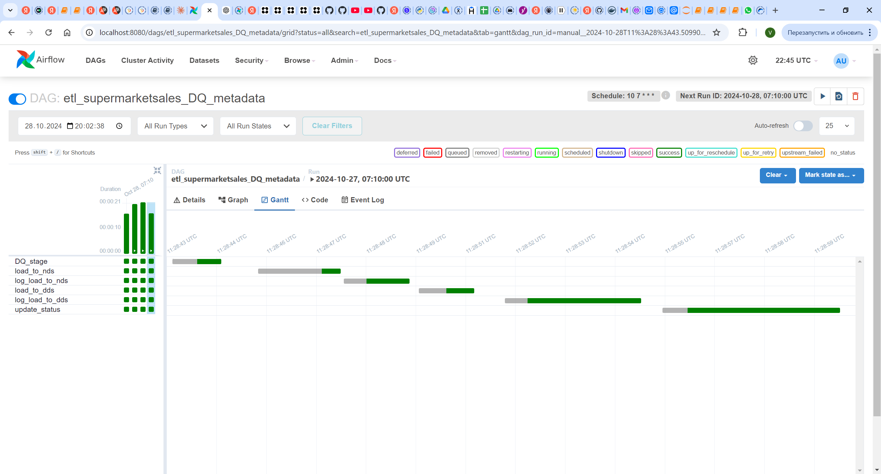

Process description
The ETL process is divided into the following stages::

Data quality check (DQ) in the stage layer:
  - Task name: DQ_stage
  - Operator used: PostgresOperator; executes the SQL script DQ_stage.sql
  - The staging layer data is enriched with the product_id attribute (synthetic data is generated), and the attributes unit_price, tax_5, cogs, total, and gross_income are updated and recalculated according to the values from the nds.products reference table. This is a necessary approach to simulate the normal operation of the data warehouse.
  - Further the initial data quality and consistency check is performed:
    - invoice_id matches the pattern ###-##-####
    - unit_price > 0
    - quantity > 0
    - tax_5 > 0
    - time is within the range from 00:00:00 to 23:59:59
    - rating is in the range from 0 to 10
  - Data that fails the checks is sent to the dq schema of the supermarketsales database, specifically to the table dq.stage_kaggle_sales, for review by the data engineer or the responsible employee for the source data.
  - Data that did not pass the data quality check (DQ) is removed from the stage.kaggle_sales_ready table.
  - Task result:
- Data in the stage.kaggle_sales_ready table is prepared for transfer to the nds layer.
- Initial quality control of the data has been performed; data that failed the checks has been sent to dq.stage_kaggle_sales

Loading Data into the NDS Layer:
  - Task name: load_to_nds
  - Operator used: PostgresOperator; executes the SQL script ETL_DQ_nds.sql
  - In the first step, the dq.nds_orders and dq.nds_invoice_customers tables are cleared, simulating the review of poor-quality data identified in this task
  - An anomaly check is performed on the data, specifically checking for extreme values in the number of orders placed in a single day. The threshold for triggering this check is set at a 3-fold increase over the average number of orders per day
  - Data that fails the DQ checks is sent to the dq.nds_orders table with the identifier issue_id = 7, after which the data is cleared from the source in the stage.kaggle_sales_ready table.
  - A logical check is performed to ensure that one order can only have been processed by one customer.
  - Data that fails the DQ checks is sent to the dq.nds_invoice_customers table with the identifier issue_id = 8, after which the data is cleared from the source in the stage.kaggle_sales_ready table.
  - Remaining data in stage.kaggle_sales_ready is loaded into the nds layer, specifically into the nds.orders table and nds.payments.
  - Task result:
- Data from the stage.kaggle_sales_ready table has been loaded into the nds.orders and nds.payments tables
- Data quality checks have been performed; data that failed the checks has been segmented and sent to dq.nds_orders and dq.nds_invoice_customers;

Logging the Load to the NDS Layer
  - Task name: log_load_to_nds
  - Operator used: PythonOperator; executes the function log_metadata_initial
  - During the logging process, information such as the DAG name, the name of the previous task, the execution time of the previous task, and the number of rows processed is saved.
  - Task result: Metadata about the execution of the load_to_nds task is stored in the metadata schema, specifically in the etl_status table.

Loading Data into the DDS Layer:
  - Task name: load_to_dds
  - Operator used: PostgresOperator; executes the SQL script ETL_DQ_dds.sql
  - In the first step, the average number of orders at the time of loading data into the DDS layer is recorded, along with the average order amounts for the entire data history.
  - Incremental insertion of data from the nds layer into the corresponding tables of the dds and fact layers is performed; the fact.sales_items table and dimension tables in the dim schema are populated with new data.
  - The average number of orders is recorded again, but this time considering the newly inserted data.
  - Information about the difference between the measured indicators is written to the dq.dds_trends table.
It is assumed that the data in the dq.dds_trends table can serve as an indicator in the event of significant deviations of the average values from the trend line.
  - Task result:
    - data from the nds layer is loaded into the dds layer.
The architecture of this data layer is a "star" schema.
    - Aggregate metrics are loaded into the dq.dds_trends table for further analysis.
  - Logging the Load to the DDS Layer:
  - Task name: log_load_to_dds
  - Operator used: PythonOperator; executes the function log_metadata_initial
  - During the logging process, information such as the DAG name, the name of the previous task, the execution time of the previous task, and the number of rows processed is saved.
  - Task result: metadata about the execution of the load_to_dds task is stored in the metadata schema, specifically in the etl_status table.

Updating Statuses in the Metadata Table
  - Task name: update_status
  - Operator used: PythonOperator; executes the function update_statuses
  - In this step, the public.task_instance table from the internal Airflow database is queried to obtain the correct statuses of the previous tasks.
  - Task result: metadata about the execution statuses of the load_to_nds and load_to_dds tasks is stored in the metadata schema, specifically in the etl_status table.

Parallel update of Power BI dashboards
This is an optional task that is not implemented in the project.
After the loading into the DDS layer is complete, a task can be added to refresh reports in Power BI.

ETL process Topology
- Implemented Topology:
DQ_stage --> load_to_nds --> log_load_to_nds --> load_to_dds --> log_load_to_dds --> update_status

- Possible Improvement:
DQ_stage --> load_to_nds --> log_load_to_nds --> load_to_dds --> log_load_to_dds --> update_status
|
(in parallel)
--> Power BI Data Mart refresh
In this project, it was not possible to implement this, as the use of the Power BI API is only available in the paid version.

Possible enhancements and improvements
- Automating the Power BI refresh after the loading process is complete.
- Optimizing SQL scripts and index tuning to enhance performance
- Setting up alerts in case of DAG failures

Data that did not pass quality checks
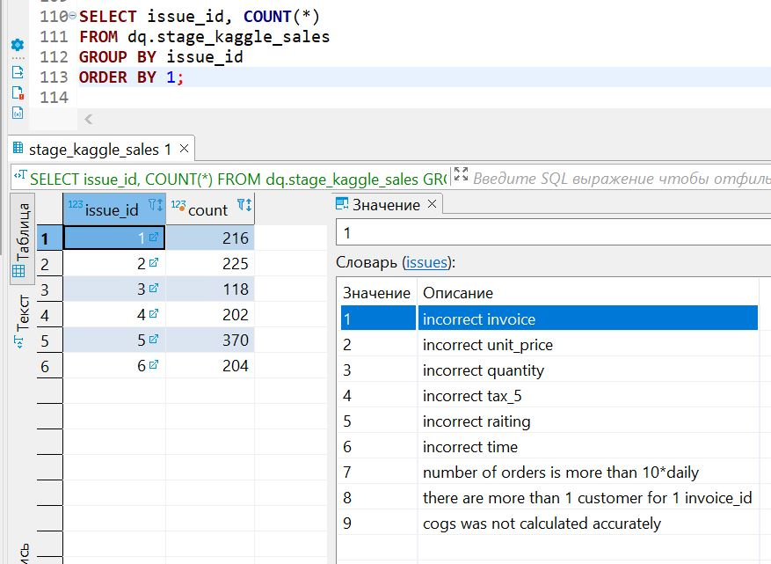 | 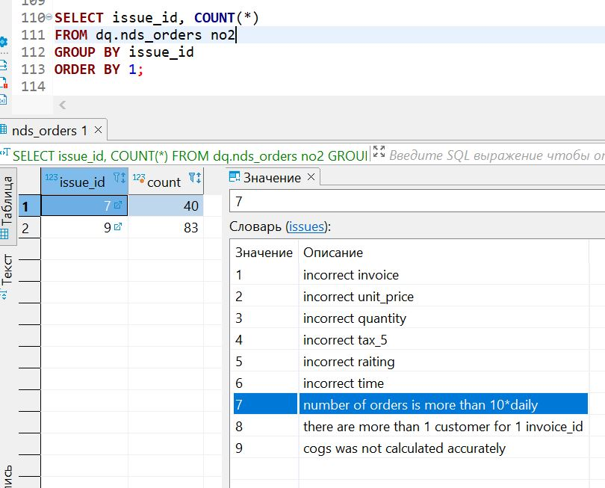
Figures 1-3
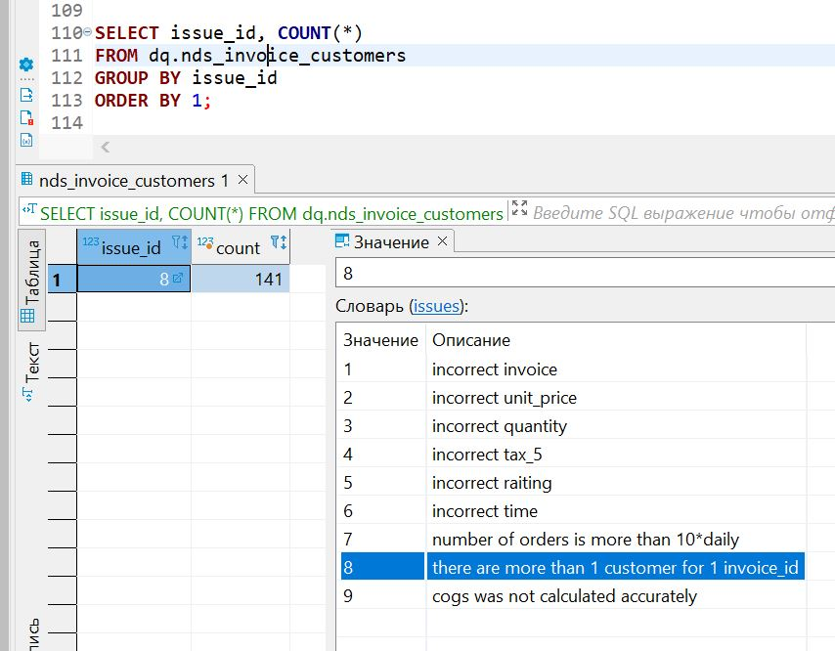

Data Transformation with dbt

Tasks of the Section
dbt was used as an alternative tool for data transformation purposes in an educational context. Its use was not mandatory in this case and led to some duplication of functionality between Airflow and dbt, but the goal was to get hands-on experience with dbt.
Within this project, dbt solves the following tasks:
- Detects anomalies in the number of orders per day at the model level.
- Transfers data from the stage layer to the NDS layer (implemented with the example of the dbt.orders table).
- Creates snapshots of selected relationships, implementing data history (SCD Type 2) (implemented with the example of the dbt.orders table).
- Generates automatic documentation for the project.
Important and useful features such as automatic data testing and the use of macros were not covered in this project.

Connection Setup
Following the official guide's recommendations, a separate virtual environment in Python was created named dbt-env.
Then, dbt-core and the necessary adapter (PostgreSQL) were installed, and the connection to the supermarketsales database was configured in the profiles.yml file:
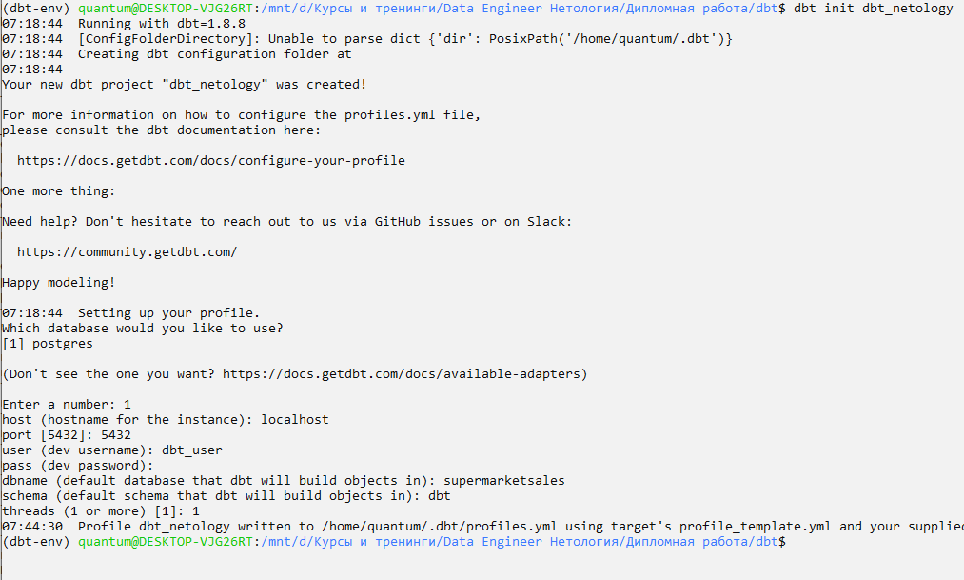
After creating the dbt project (using the dbt init command), it becomes possible to configure the dbt-project.yml:
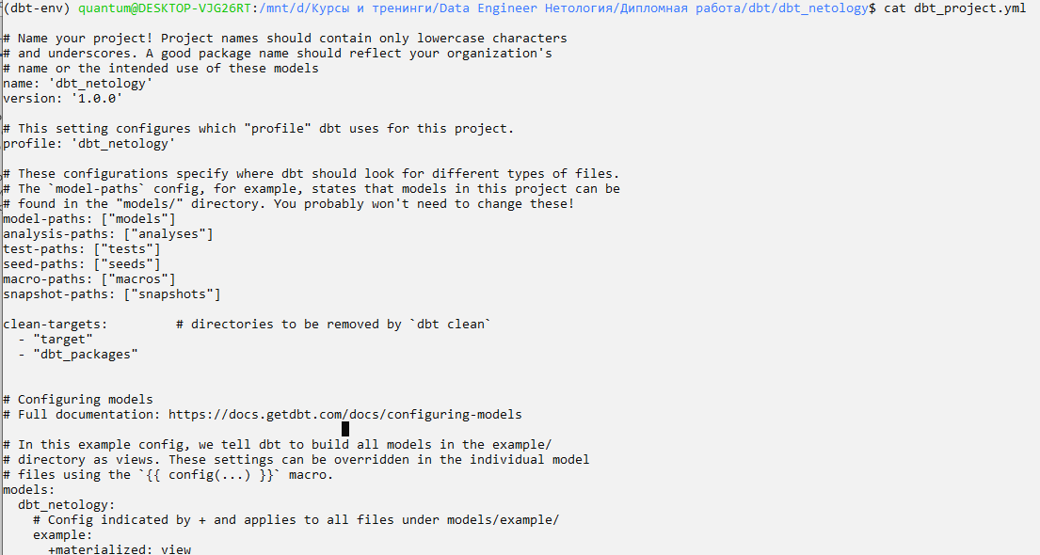

The dbt debug command allows to verify the correct connection settings:
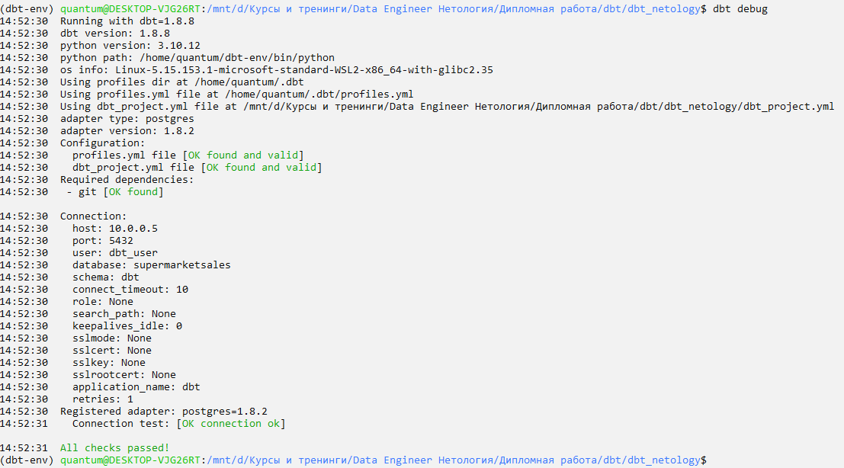

  - DAG Setup / Managing Model Dependencies
Due to the simplicity of the models, a DAG was not created.
However, it is assumed that, if necessary, the ref operator will be used to set up the DAG and manage model dependencies.

Model Descriptions
The main approach when writing dbt models is to have one DML/DDL operation per model. If necessary, dependencies between models are configured, thereby setting up the DAG.

For each model, a corresponding SQL script is created, which is stored in the ./models directory.

- bad_dates: This model performs the same check as the load_to_nds task in Airflow – it checks for anomalous outliers in the number of orders per day. The identified dates are recorded in the dbt.bad_dates table.
The model uses the materialization parameter {{ config(materialized='table') }}
- orders. This model performs incremental loading of cleaned data into the dbt.orders table.
The model uses the materialization parameter {{ config(materialized='incremental', unique_key='invoice_id') }}.
The models are executed with the dbt run command.
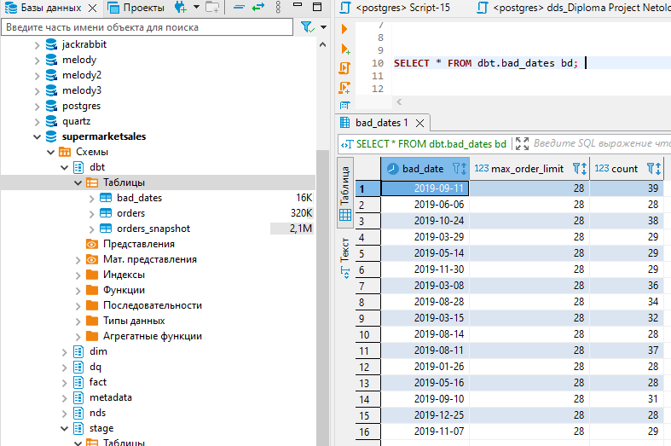

Snapshot Descriptions
Snapshots are used to create versioning of data, allowing tracking of changes over time while preserving historical records in tables.
In the ./snapshots folder, one snapshot script (orders_snapshot.sql) has been created for the dbt.orders table. This snapshot automatically tracks changes in the product_id and customer_id fields.

The tracking strategy used is check.
dbt compares the values of the specified fields in existing snapshot records with new values from the source table. If any field differs, the record will be updated or added.

Another strategy, timestamp, could have been used, but in that case, a versioning attribute based on the record's creation time (e.g., the ‘updated_at’ field) would need to be added.
  - Creating Documentation
In order to create documentation describing the used models and snapshots, a models.yml file was created in the ./models directory.
Then, the following commands were executed to generate the documentation and start the server to view it:
dbt docs generate
dbt docs serve --port 8081 (port 8080 is occupied by Apache Airflow)
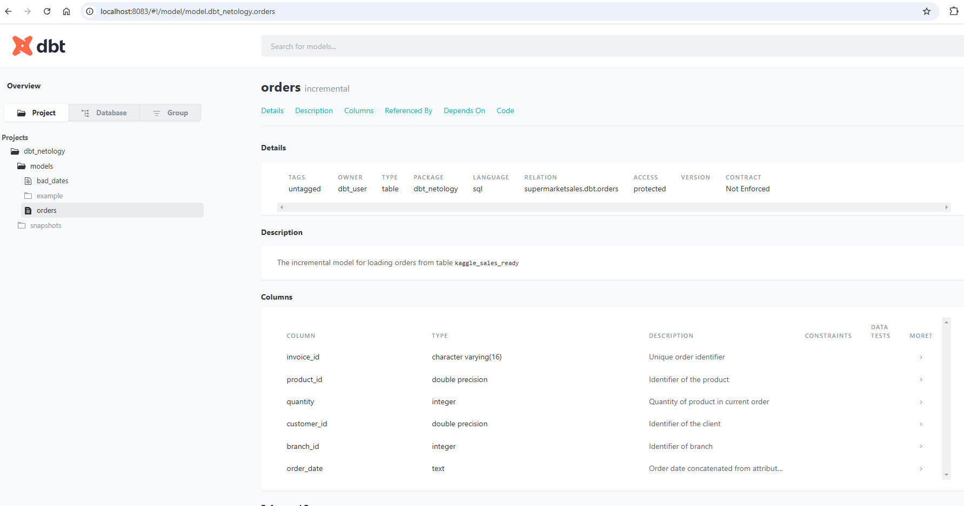

Results and Conclusions
The following tasks were accomplished within the project using various technologies:
No. | Task Completed | Technology Stack
1 | A data warehouse was created, and DDL and DML scripts were written for all layers of the data warehouse | PostgreSQL
2 | A daily report generator was created, simulating both "correct" data from a DQ perspective and erroneous data | Python  Docker
3 | Orchestration of daily report loading was set up | Crontab  .bat script (SQL script execution) PostgreSQL stored procedure
4 | A DAG was created to implement ETL processes for loading data into the data warehouse, validating it, and logging ETL task statuses | Apache Airflow
5 | Dashboards were built based on the data mart layer | Power BI
6 | dbt models have been configured for an alternative ETL process setup and data quality (DQ) checks | dbt

The construction of the NDS and DDS layers allows for efficient storage and analysis of data, while the creation of dashboards helps visualize key metrics and improve decision-making processes.
The project demonstrates the potential for using ETL processes to automate data loading and provide flexibility in configuration and scaling.
Additionally, data quality control and tracking of uploads are implemented through the metadata layer.

